The Space Adventure

Objectives:
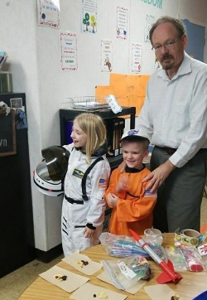
- Students will understand that gravity is a force exerted by matter and that the force is greater on the Earth’s surface than in space.
- Students will understand that man must make adaptations to survive in various and different environments.
- Students will understand the importance of engineering and design required to place man in space.
- Students will design and launch a rocket based on information acquired during the unit.
- Students will try fruits and vegetables that are new to their diet.
- Students will understand the importance of cooperating in order to achieve goals.

Frameworks and Standards:
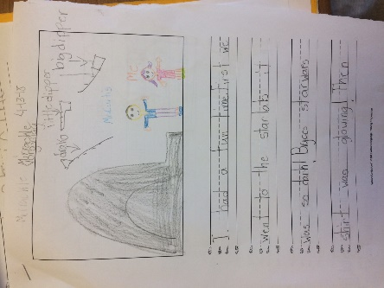
ETS1.A Defining and delimiting engineering problems.
B. Developing possible solutions.
C. Optimizing the design solution.
PS2.A Forces and Motion- Forces act on an object and have both strength and direction.
LS4.D Biodiversity and humans.
ESS1.A The Universe and its Stars.
B. Earth and the Solar System.

Materials Needed: (Space presentation)
- Space suits of various sizes. Space helmet (orientaltrading.com).
- Space ice cream (NASA)
- Dried fruit, tang™
- Sandwich size baggies
- Straws
- Space robots (Educational Innovations, www.TeacherSource.com) Not required.
- Pitcher to make tang, stirring spoon.
- Bathroom small cups or containers for fruit.
- Various types of rockets for demonstrations. (Flinn. Educational Innovations)
- Planet X notes, worksheet, attached.
- Space stickers, passports (orientaltrading.com),
Procedure:
Introduce the lesson by explaining to the students they are in the NASA astronaut training program. They are getting ready to launch into space. If successful in training, they will get an astronaut badge upon completion. You can also issue a passport to each if you wish. Passports contain stickers that the students can access as they proceed through the program.
Space video: INSERT
Demonstration of various types of rockets. Launch the space canister without any engineering and discuss why we must design rockets. The canister will tumble end over end because it is flat. Discuss why rockets have a cone and fins.
Launch a alka seltzer powered canister by placing one-half alka seltzer tablet into the 35mm clear canister, pouring it half full of water, tightening the lid, and setting upside down on the floor. (Make sure students are not seated in the area of the launch). The canister will launch 40 or more feet into the air or will collide with the ceiling in the regular classroom.
Discuss fuel and Newton’s third law although it is just introductory at this age. Fuel exits the bottom, rocket moves upward. Discuss the amount of power needed by the rocket to overcome gravity.
Demonstration of gravity and effects on students. Kids and teachers reinact a launch and what it might look and feel like.

Space Environment: If we travel to Alaska or to Costa Rica, we have to be prepared for the environment there. It might be very cold or very warm so we would have to dress appropriately. The food we eat might be very different. How about in space. Discuss the space environment with students. Bring one of the students up to try on the suit. Generally, I pick a small girl because we want to emphasize that girls can be scientists as well as astronauts.
The orange suit is ground control. Have the student dress in it. Would he need to wear the helmet? He is on Earth so he wears a cap. What does ground control do? (keep the shuttle running, communicate with astronaut, place food in shuttle, fix problems). Who will get attention and be on TV? Point out that the astronaut needs the ground crew to get her job done. Sometimes we are ground crew in our world. Everyone cooperating is what makes our world work!! Our magic word for the lesson is COOPERATE. We have several suits and leave them with the school so all students can try them on and get a picture. Often, teachers have them write about being an astronaut and downloads their photo in their space book. Great for parent nights.

Space Food: What is it like to live in space? Show the video (INSERT).

Discuss eating and living in zero G. The kids will try out Tang ™ in sandwich bags as well as the dried fruit. Trying new fruits and vegetables is a k,1 standard so this allows the teacher to let the kids experiment with new foods as well as teach that astronaut food is often dehydrated to save space and weight. We also provided small samples of space ice cream.
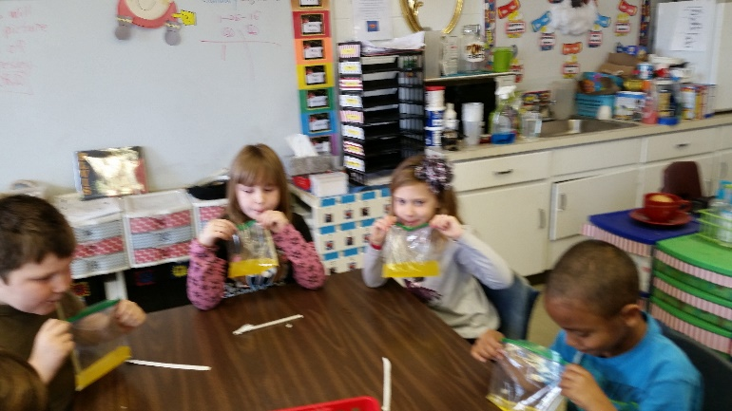
Students experience drinking food in space. Tang was an original space drink of the 60's and 70's.
Engineering:
Use the attached lessons and allow students to design a rocket using 35 mm canisters and 2 liter bottles.

Culminating Activity:
All students report to the launch pad for Journey to Planet X. Launch any of a number of outside rockets. I have used 2 liter water bottle rockets, stomp rockets of various kids, and ESTES rockets.
Stomp rockets and launch can be purchased from BlackJack Science at (insert)

Journey to Planet X
Crew Name:_______________, ________________,_______________,_____________
Crew home base (school)_____________________________
You and your crew are assigned the task of developing a vehicle that can safely travel to Planet X. Planet X is a barren planet and will require a long journey before arrival. Your first task is to design a canister that will travel for the greatest distance. You will be given materials that you can use to design your rocket, a bottle that will provide fuel for your rocket, and, upon completion, you will fire your rocket from a launcher provided by headquarters. Your rocket will be attached to the end of the launcher by simply inserting it over the fuel exit (pipe). You will be able to adjust the angle as desired to launch your rocket for maximum distance. Distance is measured in a straight line to the point where your rocket comes to a COMPLETE STOP (bounces and rolls are counted).

Distance achieved. ________________cm

Planet X has an atmosphere similar to Earth. For your survival, it is necessary for you to land your rocket within a prescribed landing zone ( trash can). The landing zone will be locate three meters from your launch pad. Using your second canister, construct a rocket that will land within the zone. You will be given one practice shot which WILL Not be counted and one opportunity to land your craft within the zone. You may choose to forgo the practice by telling the official BEFORE you launch. Using the second canister and the same launch pad, your task is to land within the zone.
Landing at the (inside) launch site: __________________plus 100 cm
No points awarded for hitting the
Each team will receive the following materials. They can be used in any manner chosen by your group.
Two Blank canister glue scissors construction paper (half sheet) plastic bag
Meter stick popsicle stick paper clips as needed two liter soda bottle
Scotch tape construction tape available 12 inch string three soda straws
Four rubber bands sandwich bag (Pens and markers available)

Total points for team: Distance traveled _________plus ___________LZ bonus=_________
Journey to Planet X, Middle School Lesson

Objectives:
- The student will understand the concept of Boyle’s law. Boyle’s law states that if you decrease the volume of the container of gas, the pressure of that gas will increase, providing the temperature remains the same.
- The student will review skills relating to measuring mass, distance, and volume in metric units.
- The student will construct and record mass and distances on a data table.
- Students will construct a graph plotting weight vs. distance.
- Students will be able to correlate effects of weight on distance traveled.

Arkansas and National Frameworks:
- NS 1.1-12 Scientific method, research design
- PS.6.6.3 Conduct investigations using SI measurements.
- PS.6.6.6 Compare and contrast weight and mass.
- PS.6.7.2 Compare and contrast Newton’s first law of motion.
- PS.6.6.7 Describe the effects of force.
- PS.6.5.6 Potential and Kinetic energy.
- P.6.PS.1 Analyze how force affects motion.
- P.6.PS.5 Interpret graphs related to motion.

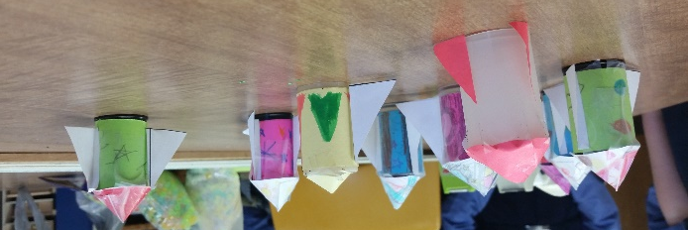
Materials Needed:
- Launcher
- Several 2 liter bottles
- duct tape
- meter stick or tape
- scales
- cone and fin sheet
- glue
- graph paper/ data table sheet
- Protractor or instrument to measure angle of the launcher.

Procedure:
Each group is supplies with a 35 mm film canister, cone and fin sheet, glue, graph paper and data sheet. Student groups are than instructed to devise a rocket from the materials with the goal or developing a design that will fly for the greatest distance. Rockets are weighed when completed and the information recorded (in grams) on the data sheet.
Students discuss and set the angle for the launcher so that all groups use the same angle. Other variables such as who stomps the 2-liter bottle and wind can be discussed with the students at this time. Try to eliminate all variables except mass.
Each group is allowed one opportunity to use their rocket and the distance is measured using the meter stick. Convert all distances to cm (allows practice in SI). Record the information on the data sheet. When all groups have completed their launch, you might demonstrate flight of an empty canister. The empty canister usually travels much farther than those having wings and fins.
Groups should exchange launch data and record the information on the data sheet. Each group is than to devise a bar graph plotting distance travel (y axis) vs. weight (x axis).

Constructing a launcher:

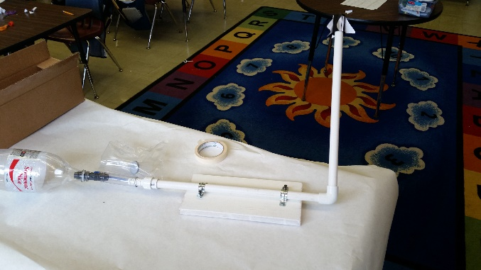
Use one inch PVC pipe (purchased at any housing materials store). Cut the PVC (usually purchased in 8 ft. lengths) into 12 inch long segments. Connect two segments with a 90 degree PVC elbow so that the segments are at right angles to each other. Use PVC glue so that the pieces are held securely. A six-inch long 2 by 4 inch board is used as the base. It is attached to the bottom segment of the PVC pipe using plumbers tape (supply store) and hammer/nail. The two liter bottle is than attached to the bottom segment by inserting the PVC pipe into the bottle opening and sealing with duct tape. Rocket is launched by student stomping upon the bottle. The propellant is than air pressure. The air pressure increases as the container’s volume decreases. The 35 mm canister is inserted over segment two and is propelled by the pressure from the bottle. This is a perfect example of Boyle’s law: As volume decreases, pressure increases as long as temperature remains the same.

Extensions:

- Construct a rocket that will land in a designated area. I mark off about 2 m and place my trash basket. Most successful rocket is the one that lands in the basket.
- Allow the students to test the rocket using one, two, and three liter bottles and note or graph the results.
- Construct a line graph instead of the bar graph.
- Allow the student to experiment with the launcher using different angles and record differences in the flight of the rocket.

Student Work Sheet: Soda Pop

Group Name | Weight of rocket in grams | Distance rocket traveled  in cm

