Neutral Buoyancy __________________________________________________
Mission
Participants will investigate how objects float, sink, or hover in water by constructing a neutrally buoyant astronaut.

Background

Buoyancy (or the Buoyant Force) is the tendency of a body to float or to rise when submerged in a fluid. It is indicative of the ability of a fluid, such as air or water, to exert an upward force on a body placed in it. Buoyancy determines whether and object will float or sink. It measures the difference of an object’s density or how much space it takes up in comparison to its matter, and the fluid or gas it moves. Buoyancy measures two opposing forces. One force is the downward pressure of the object on the fluid. The other force is the upward pressure on the fluid on the object.

The Neutral Buoyancy Laboratory is NASA’s facility for training astronauts to complete Extra Vehicular Activities commonly known as spacewalks. The NBL is in Houston, Texas close to NASA’s Johnson Space Center. Facilities there include a large pool 202 ft (61.56 m) in length, 101 ft (30.78 m) in width, and 40 ft (12.19 m) in depth. The average pool temperature is around 85 degrees to assure a comfortable environment for the divers aiding the astronauts during training.

Astronauts suit up in a 4.2 PSI pressurized suit that allows the astronauts to breathe Nitrox, a combination of Nitrogen and Oxygen. The suited astronauts are lowered into the water by a small JIB crane that is attached to a submerged donning stand. Support divers are there to help release the astronauts from the stand and begin to weigh them to achieve neutral buoyancy.

The divers position the astronauts on their backs and identify any parts of their bodies that rise or sink. Positively buoyant, rising parts are weighted and negatively buoyant, sinking parts have weight removed. Astronauts experience neutrally buoyancy to simulate the feeling of floating in space.

Scientific Terms

Positive Buoyancy occurs when an object is lighter than the fluid it displaces. The object will float because the buoyant force is greater than the object’s weight.
Negative Buoyancy occurs when an object is denser than the fluid it displaces. The object will sink because its weight is greater than the buoyant force.
Neutral Buoyancy occurs when an object’s weight is equal to the weight it displaces.

Materials
- Small plastic toy (rubber duck)
- String, rubber band, or cup hook
- Pipe cleaners
- Paper clips (large & small)
- Washers of different weigh
- Large water container (aquarium), filled to depth to allow toy to be submerged
- Towels

Approach
- Fill large clear water container ½ full of water. A cutout of the NBL may be affixed to the outside of the water container.
- Distribute 1 rubber duck astronaut to each participant. Each duck should have a means such as a rubber band, string, or cup hook attached to allow attachment of additional materials.
- Distribute assorted attachment materials of varying weights.
- Place the astronaut in original condition into the water and observe what happens.
- Add ore materials to the astronaut to change its position (depth) in the water.
- Observe how far the astronaut sinks in the pool of water. The optimum distance would be ½ way from the top of the water to the bottom of the water.
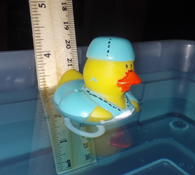
Extensions and modifications:
- Adjust your depth by removing or adding materials to your astronaut based on the location in the pool you're trying to get too.
- Once neutrally buoyant, add a string to the astronaut and maneuver your astronaut to different locations in the water container.
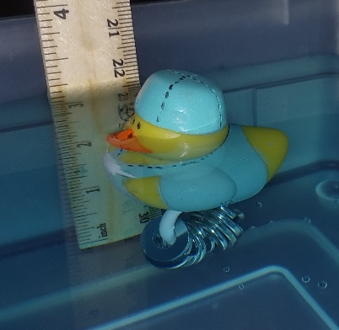
- Modify the salinity of the water by adding salt to see what effects that has on a neutrally buoyant astronaut.

Follow up Questions
- What materials did you use to make your Astronaut duck neutrally buoyant?
- What happened to your astronaut when placed in the water the first time?
- If density is defined as the mass divided by the volume of an object, how does the density of an object affect its ability to become neutrally buoyant?

For more info:
https://www.calacademy.org/sites/default/files/assets/docs/pdf/035_buoyancybullseye_updated_2.pdf
https://www.nasa.gov/pdf/583432main_AP_ED_Stats_SpacewalkTraining.pdf
https://sciencing.com/three-types-buoyancy-10036718.html

