Supply List SEEC
Buoyancy Activity 1
- Clear container (drinking glass, storage container) ¾ filled with water
- Small (0.5” in length) object that floats such as a candle, cork, Styrofoam packing peanut, piece of sponge
- 10-15 paper clips
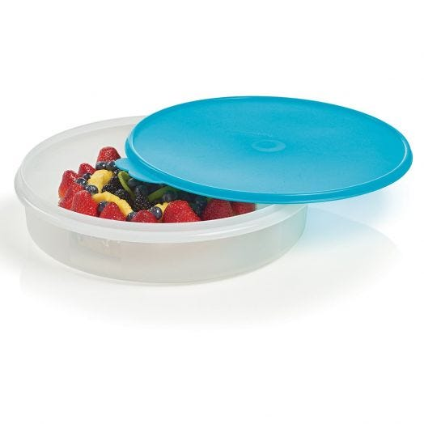
Buoyancy Activity 2
- Shallow, clear storage container (1 quart), filled to brim with water (like figure provided, no lid needed)
- Larger storage container to hold first container
- Aluminum foil cut to 6”x6” pieces
- 2-3 drinking straws
- Scotch tape and scissors

