Presentation Resources and Videos

*ISS 20th Anniversary Sizzler Video: https://www.youtube.com/watch?v=yq8Vx7yiysg&feature=youtu.be

STEMonstrations: https://www.nasa.gov/stemonstrations
In-flight Education Downlinks: https://www.nasa.gov/audience/foreducators/stem-on-station/downlinks.html
Microsoft Hacking STEM NASA Lesson Collection: https://education.microsoft.com/en-us/hackingStem/nasa
Expeditionary Skills for Life: https://www.nasa.gov/audience/foreducators/stem-on-station/expeditionary-skills-for-life.html
STEM on Station: https://www.nasa.gov/audience/foreducators/stem_on_station/index.html

Celebrating Station Science: https://www.nasa.gov/audience/foreducators/stem_on_station/celebrating-station-science.html

*Science Casts: Space Gardening: https://youtu.be/M7LslyCX7Jg
*Exercise STEMonstration Video: https://youtu.be/lssYrWDvv6w

Exercise STEMonstration Classroom Connection: https://www.nasa.gov/sites/default/files/atoms/files/bone-density-and-muscle-stress-in-microgravity.pdf

Example Data
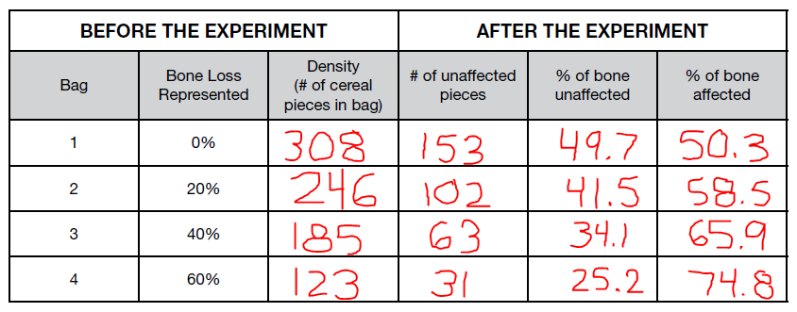

Additional NASA STEM Resources

NASA EXPRESS Sign-up: https://www.nasa.gov/stem/express
NASA Next Gen STEM: https://www.nasa.gov/stem/nextgenstem/index.html
NASA STEM: https://www.nasa.gov/stem

