ELECTROMAGNETIC ENERGIES GOT YOU DOWN?
STEAM IT UP WITH DIANEA PHILLIPS & ARGY LEYTON
SEEC 2021
MATERIALS
Things you will need in general to do our STEM/STEAM activities:
Note: See sheet in this folder.
- Color Spectrum template – www.education.com worksheet
- Blackline Master #1 Electromagnetic Spectrum Card Sort: https://science4inquiry.com/LessonPlans/NewLessons/NotVisible.pdf
- Make a Rainbow Video: https://www.generationgenius.com/activities/make-a-rainbow-activity-for-kids/
- Glue stick
- Permanent markers, markers or highlighters
- A sharpened pencil
- A penny or a washer that is the size of a penny
- Red Ted printable fidget spinner template
- Corrugated cardboard
- 1 side of a cereal box
- Ruler
- Scienc4Inquiry.com
- GHz and MHz cards
- 10ft long (3m) butchers cord, wool or string of any kind.
- 15 clothes pegs or paper clips (optional: Post It Notes)
- A fidget spinner
- American pennies or Canadian nickels (or something that compares to the size of these)
- Scissors
- Tape (always good to have)
- Toothpick or a skewer (skewer is better)
- Cup or a something to make circles with (could also be a protractor)
- Hot glue gun and one or more glue sticks (small not large)
- VIBGYOR CHART (below)

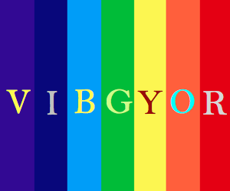
The mnemonic VIBGYOR is used in order to remember the colors easily.

