Since there are so many varieties of stellar spectra, astronomers have grouped similar spectra into spectral classes. A spectral class is the star's position in a temperature classification scheme based on the appearance of absorption lines in its spectrum. The spectral sequence, composed of the spectral classes, rearrange these spectral class from hottest to coldest as follows:

OHD-93129, 7,500 light year, 42,500 K.
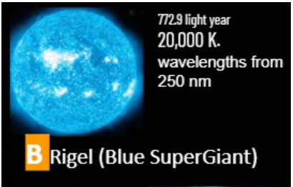
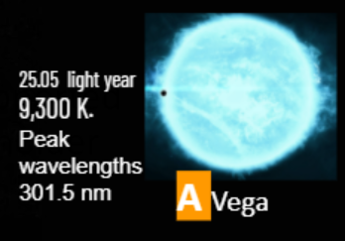
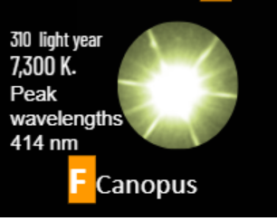

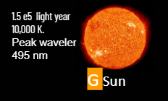
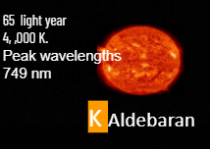

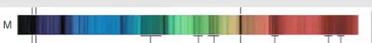
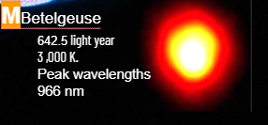

What elements are present in the F class star?

F class Star - Distinct Hydrogen and Sodium lines
Na
H

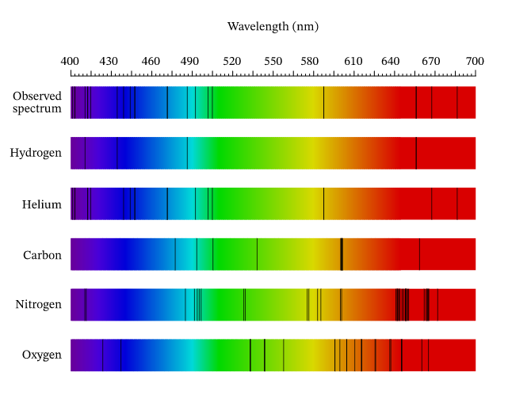
The ﬁgure shows the spectrum of light that was observed as well as the absorption spectra of several pure elements. Which of the ﬁve elements shown does the interstellar cloud contain?

Some useful links with practice Worksheets.
https://www.nagwa.com/en/worksheets/658148208480/
https://www.explorelearning.com/index.cfm?method=cResource.dspDetail&ResourceID=558
https://www.explorelearning.com/index.cfm?method=cResource.dspDetail&ResourceID=429
https://phet.colorado.edu/en/simulation/blackbody-spectrum
https://app.discoveryeducation.com/learn/videos/d2b614ea-5095-4fff-971e-d08927d340c7/
https://spacemath.gsfc.nasa.gov/astrob/5Page55.pdf

