Searching for life:
A Cryobot Mission to Jupiter’s Icy Moon Europa
Prelude to an Underwater Drone Lesson

Objectives
Students will:
- Learn how we determine the makeup of another celestial body
- Analyze data to understand the different layers of the moon Europa
- Build a 3D model cross-section of the layers of Europa
- Describe how a future mission to Europa will likely occur with a cryobot
- Define cryobot, which is “a robot that can penetrate water ice. A cryobot uses heat to melt the ice, and gravity to sink downward.”
- Demonstrate how this cryobot will penetrate Europa’s icy crust, reach its liquid ocean and explore for signs of life
- Collaborate and communicate effectively to create a future real-world NASA mission

Suggested Grade Level
5th – 12th grades

Subject Areas
Astronomy, Space Science, Life Science, Robotics, Engineering, Physical Science

Timeline
40 - 60 minutes

NGSS Science Standards
- MS-LS1-5 – Life Science: from Molecules to Organisms: construct a scientific explanation based on evidence for how environmental and genetic factors influence the growth of organisms
- MS-LS2-1 – Life Science: Ecosystems: Analyze and interpret data to provide evidence for the effects of resource availability on organisms and populations of organisms in an ecosystem.
- MS-PS1-6 – Physical Science: Matter and its interactions: Undertake a design project to construct, test, and modify a device that either releases or absorbs thermal energy by chemical processes.
2020 Colorado Academic Standards
- MS-ESS1-2 – Earth & Space Science: The solar system contains many varied objects held together by gravity. Solar system models explain and predict eclipses, lunar phases, and seasons.

21st Century Essential Skills
- Critical thinking/problem solving, Collaboration and Teamwork, Technology literacy, Carrying out investigations, Communication, Constructing explanations

Background
Liquid water is crucial to the presence of life. In the entire history of humanity’s search for life, everywhere we have found liquid water on the Earth, we found life. Scientists use this reasoning to prioritize locations to investigate life on other planets/moons/celestial bodies – meaning, if we find liquid water in space, that becomes a great target in the search for life.
The leading candidate for having an environment where life could exist is one of Jupiter’s moons, Europa. An icy crust about 15 miles thick surrounds the moon. Underneath this crust is a large, salt water ocean. This ocean is believed to be heated by geothermal vents and tidal movement from Jupiter’s gravity.
This lesson simulates a potential robot submarine (aka. cryobot) mission to Europa.

Vocabulary
Cryobot, Europa, cross-section image, thermal properties

Materials (per team of 3 or 4 students)
- Small, clear plastic cups half-filled with sand (one per team)
- Water
- Cans of shaving cream (the foamy kind, not gel) (approx. ½ cup per team)
- Marbles (one per team)
- Wooden popsicle sticks (one per team)
- Freezer
- Microwave (or access to heat small amount of water) – for teacher only
- Spoon (to scoop warm marbles out of heated water) (one for teacher)
- iPads to video - Optional

Activity Setup
- Have clear plastic cups half-filled with sand (one for each team)
- Place the follow supplies on each table to be shared by teams at that table:
  - Water in separate cups
  - Can of shaving cream (the foamy kind, not gel)
  - One marble for each team
  - One wooden popsicle stick for each team
- Have one separate small cup for teams to use to pour water into their model
- Have a separate cup for teacher to heat a small amount of water to heat marbles
- Show NASA’s 3D cross-section artwork of Europa on the wall with projector

Lesson
- Break class into teams of 3 or 4 students.
- Briefly introduce Jupiter’s moon Europa.
- Explain the cross-section image of what scientist’s believe Europa looks like.
- Explain how the students are going to make their own 3D cross-section of Europa and deploy a cryobot to search for life in their mini-Europa’s ocean.
- Give each team their cup with sand (see Image 1) and describe that they will follow your instructions to create their 3D cross-section model.
- Using the extra empty cup on the table, SLOWLY AND GENTLY pour water into their cup with sand by pouring the water onto the inside of the side walls of the cup, not directly onto the sand in their cup. This will keep the sand from stirring up and will keep their water clean. (See image 2)
- Pour enough water into their cup to be within ½ inch of the top of the cup.
- Instruct one student, away from the table, to shake their table’s can of shaving cream.
- Squeeze just enough shaving cream on top of the water to cover the water to the rim of the cup. (See Image 3)
- Use the wooden popsicle stick to gently, without mixing it into the water, spread the shaving cream so that it covers the water and seals with the entire rim. You don’t want the shaving cream to be above the rim, so scrape off any excess. Gently spread the shaving cream to cover the water and seal with the rim of the cup. NOTE: A thinner layer of shaving cream freezes quicker if this lesson is for a 40-45 minute class. (See Image 4)
- Once all cups are covered properly, bring all cups to the freezer, carrying them gently – we don’t want the water to mix with either the sand or the shaving cream. A clear ocean makes for the best experiment.
- Return everyone to class and teach details about Jupiter’s icy moon Europa – it’s properties of having a rocky core, covered with a liquid, salt-water ocean, which is covered with a crust of ice. Explain how Europa is the next most likely place we know of to potentially find life outside of Earth because of the liquid water, salt water, salt water in contact with rocky land, and thermal properties due to Jupiter’s gravitational pull on the moon.
  - To make a more hands-on lesson, instruct students to design (draw on paper, or junk engineer) their cryobot submarine. Have students include what instruments will be included on their cryobot for exploring Europa’s ocean.
- Teach (and design) for approximately 15 – 20 minutes to give the shaving cream layer time to freeze (or at least harden; frozen solid is not necessary for this lesson to work well).
- Retrieve each team’s 3D model from the freezer.
- Heat a half cup of water in teacher’s extra cup.
- Drop all teams’ marbles into the heated water, let marbles heat up for approximately 1 minute.
- Instruct teams to open their iPad’s camera to video mode (if using iPads). Start a timer.
- Retrieve one heated marble for each team and have a student immediately set their cryobot (their heated marble) on top of their shaving cream. Students should be careful not to drop the marble onto the frozen shaving cream.
- Instruct team to video their cryobot melting into Europa’s icy surface and ending up in Europa’s salt-water ocean to begin searching for life or signs of life!
- Repeat steps 19 and 20 with each team.
- Discuss teams’ results. Discuss how this experiment will mimic NASA’s first real mission to reach Europa’s liquid ocean.

Extensions
- Use this lesson in conjunction with an underwater drone driving lesson.
- Discuss other places in the solar system where this type of cryobot explorer could be beneficial in the exploration of the solar system and the search for life, including Saturn’s icy moon Enceladus.

Resources
(n.d). Europa Clipper. Retrieved from https://www.jpl.nasa.gov/missions/europa-clipper/

(2017, February 13). Descent into a Frozen Underworld. Retrieved from https://www.jpl.nasa.gov/news/news.php?feature=6743

Visuals

1 – Put sand in bottom half of clear cup

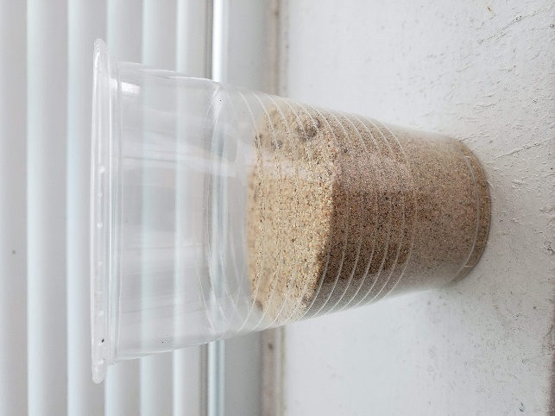
2 – Add water to within ½ inch of cup rim

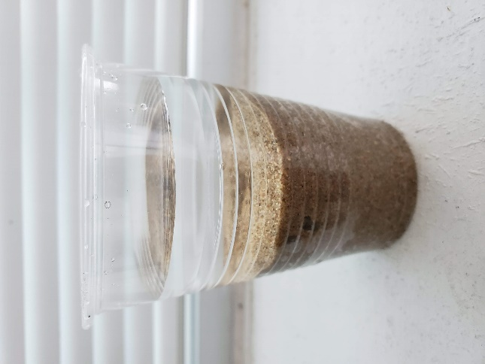

6 – Each team can watch (or video) their cryobot melt its way to Europa’s liquid water ocean below

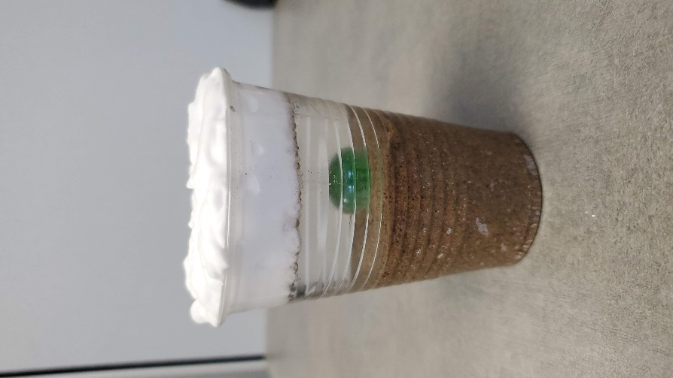
5 – After using a separate cup to heat water to warm the marbles, have each team carefully PLACE (not drop) their warm marble (cryobot) on the frozen surface.

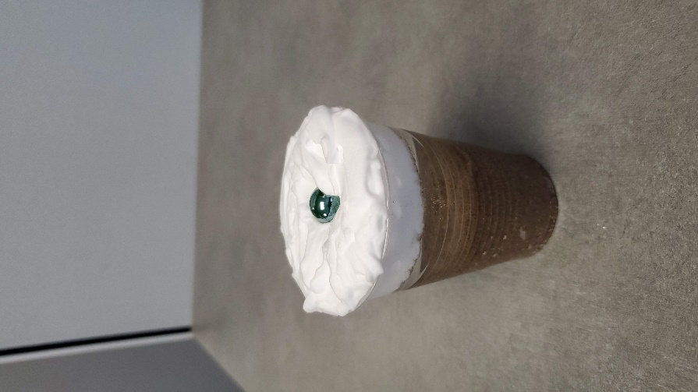

4 – Use a popsicle stick to gently spread shaving to completely cover the water across the entire cup rim.
Then place in FREEZER until shaving cream is solid, but water remains liquid.
This give the students a 3D cross-section of Europa.

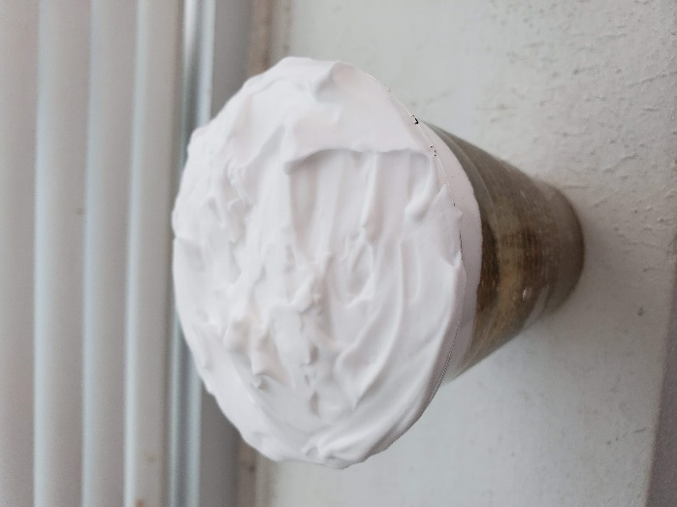
3 – Carefully add shaving cream to cover the top of the water, being careful not to mix the shaving cream and water. We want the water to remain clear.

