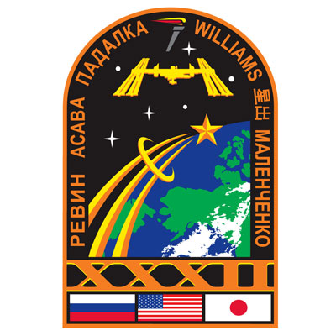
Design Your Own Crew Patch

When astronauts are selected for a space mission they design, as a crew, a patch that represents their mission and its objectives. The first crew to have an official crew patch was the crew of Gemini 5 in 1965.
The Gemini 4 crew was the first to have the American Flag on their space suit. Every crew since Gemini 5 have had a flag, mission patch, NASA patch and name tag on their space suits.
Your activity is to design a patch for your Young Astronaut School Group, your country you are representing or your specific team/country. You can design your patch free-hand or use the template provided.
Here are some samples of mission patches and their meaning:

The STS-41B (10th shuttle mission) patch represents a mission of many firsts. The center point of the patch represents the first ever landing at the Kennedy Space Center, the left circle represents the two satellites launched on the mission and the right circle represents the first ever untethered space walk.

The third expedition patch for the International Space Station highlights the former dockings with the Russian Space Station Mir on the left, leading to the sunrise over the new program of joint flights to the International Space Station; the space walker represents the construction of the space station, while the book represents the lessons learned and history being made.

A Sampling of Space Shuttle
and Space Station Patches

